Omagh North Nursery School’s



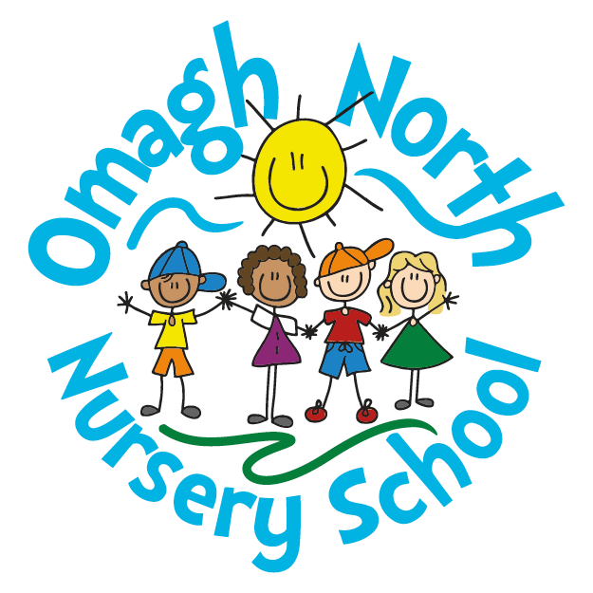

**Learning and Teaching Policy**

It is the aim of Omagh North Nursery School to ‘provide perfect preschool experiences’ and to lay the foundations for a lifelong love of learning. Through the teaching at Omagh North Nursery School we equip children with the skills, knowledge and understanding necessary for their everyday lives. We believe that the purpose of teaching is to prompt effective, active learning experiences which enrich the children and help them to lead happy and rewarding lives.

This policy seeks to secure consistency in classroom practice and management, and to identify the ways in which teaching, and learning are characterised in order to create a consistent, effective and well managed learning environment in which the individual needs of each child can be met.

**School Aims**

As a community pre-school provider, we are privileged to have been entrusted with providing children with firm foundations upon which to build their education. With that in mind it is the aim of Omagh North Nursery:

* To provide learning experiences in line with the Pre-School Curricular Guidance and Planning for Learning for 2-3 year old children – NI.
* To create an environment that is caring, supportive, familial and inclusive.
* Develop understanding, appreciation and respect for the environment and the world.
* Develop practical skills and provide opportunities to apply these creatively.
* To use ICT to support, enhance and record children’s learning experiences.
* Help children develop physically and become aware of the need for exercise and a healthy lifestyle.
* Encourage children to develop positive attitudes, perseverance, self-esteem and self-confidence.

**Teaching and Learning**

At Omagh North Nursery School, we acknowledge that children learn in many different ways and we recognise the need to develop strategies that allow each child to learn in the ways that best suit them. We believe that effective and purposeful learning will take place when children are;

• Feeling safe, secure, confident and aware of boundaries.

• Interested and motivated.

• Aware of routines which define the nursery day.

• Given tasks which they clearly understand, and which match their ability.

• Engaged in problem solving, investigational activities and structured play.

• Involved in creative learning experiences.

• Are challenged and stimulated.

• Able to work independently using their knowledge and skills relative to their ability.

• Given praise and approval for successful work and achievement.

• Interacting positively with peers and adults.

• Working with others to achieve their learning goals.

• Asking questions to develop their knowledge, skills and understanding.

**The Learning Environment**

Children learn best when the environment in which they find themselves is ordered, well managed and carefully planned to motivate and engage. In order to maximise the learning environment in the school, we believe that;

* Everyone should take pride and responsibility for the environment provided at Omagh North Nursery School.
* Classrooms should be welcoming, well organised and resourced.
* Classrooms should celebrate the children’s learning and should reflect throughout the school year the breadth of the Pre-School Curriculum/ Planning for Learning for 2-3 year old children – NI.
* Classrooms should be organised to enable the children to use and follow clearly defined procedures and routines through the visuals on display (e.g. daily classroom routines, snack time etc.) and provide floor space to deliver Planning for Learning for 2-3 year old children – NI.
* The layout of the furniture in the classrooms is reviewed and varied to meet the requirements of the subject matter or particular learning need.
* Resources should be reviewed continually to ensure that only those suitable are offered to the children for both preschool and penultimate children.
* Resources should be appropriate, well maintained, labelled and organised in such a way to enable the children to be as independent as possible.
* Reading areas /quiet areas should be welcoming and encourage children to explore books and enjoy quiet time.
* ICT equipment should be available and used as a tool to aid learning or support teaching.
* Art /creative material resources should be presented in an attractive manner and promote independence.

**Displays**

In each classroom the children’s work should be celebrated, valued and displayed attractively. Attention should be drawn to the displays to stimulate further the work in progress and reward completed efforts.

The work displayed should be representative of the children’s efforts and ability. They should use both 2D and 3D in a variety of media, colours and themes. Displays should be changed and updated frequently and cover different aspects of the Pre-School Curriculum/ Planning for Learning for 2-3 year old children – NI.

**Routines and Rules**

Routines and rules provide a context within which children can learn and contribute to a healthy learning environment. To be effective they should be;

* Shared with the parents (via Schools NI Message System) and children and be clearly understood.
* Realistic and positive.
* Kept to a minimum, but always enforced.
* Fair and consistent.
* Displayed clearly both inside and out.

The classroom rules and daily routine should result in the children clearly knowing the boundaries of behaviour, as set out in the terms of the Behaviour Management Policy.

**Opportunities for Learning**

Through our teaching and daily routines, we offer opportunities for the child to learn in different ways, which include;

* Experimentation, investigation, and problem solving.
* Group work
* Story time and discussion (small groups and whole class)
* Independent work
* Structured play.
* Role play.
* Physical activities.
* Asking and answering questions.
* Use of ICT facilities.
* Creative activities and mark making.
* Watching educational videos and responding to musical stimulus.
* Making and building models.

Modified to suit the developmental needs of the penultimate children.

**Characteristics of Teaching**

To secure consistency in classroom practice and management and therefore promote an effective and consistent learning environment and learning opportunities, teaching in our Nursery shall have the following characteristics;

* Planning is done with clear learning objectives. These objectives shall be taken from the Pre-School Curriculum Guidance/ Planning for Learning for 2-3 year old children – NI and are to provide children with the opportunity to develop to their maximum potential.
* The planning documents recognise the differing abilities of children and will differentiate the learning tasks and appropriate challenges to children’s needs noted as ‘Action for Specific Children’.
* Assessment is carried out through a mixture of informal observation, interaction with the child, the use of the information on observation sheets and discussion during regular staff meetings. The information gathered during the assessment process will then inform and influence the planning for individual/group needs.
* The teaching staff will endeavour to manage time, resources, children groupings and nursery assistants effectively to develop the learning of knowledge, skills and understanding.
* The teaching staff will ensure that the visual displays in the classroom are effective, relevant and kept up to date with the topics being taught.
* It is a priority of all staff to ensure that the children feel safe, secure and motivated at all times in the school.
* All staff will use a variety of teaching methods, strategies and styles to suit the topic being taught and whole class/group/individual needs.
* All staff will endeavour to give the children simple, clear explanations/instructions so that the children know what is expected from them and why.
* All staff will encourage high expectations about behaviour, quality of presentation of work and personal effort. When children display challenging behaviours, the sanctions and guidelines outlined in our Behaviour Management Policy will be followed.
* All staff will make it known that individuals matter, and that all children’s contributions are valued.
* All staff will provide the children with opportunities for self-expression and self-reflection. The staff will endeavour to provide the child with positive and constructive feedback. We praise children for their efforts, and in doing so help build positive attitudes towards school and learning.
* The staff will strive to develop and work in an effective partnership with the children’s parents/carers and will ensure that they are kept informed about their child’s development and progress.

**Monitoring and evaluation**

This policy will be reviewed and monitored in line with the school’s policy review schedule.

Ratified by Board of Governors on 10th April 2018.

Reviewed and Ratified by Board of Governors on 15th June 2021

Signed Chairperson: _________________________

Date:___________________