PRIVACY NOTICE
FOR
PUPILS & PARENTS/FAMILIES/CARERS/LEGAL GUARDIANS REGARDING USE OF PERSONAL INFORMATION IN
OMAGH NORTH NURSERY SCHOOL
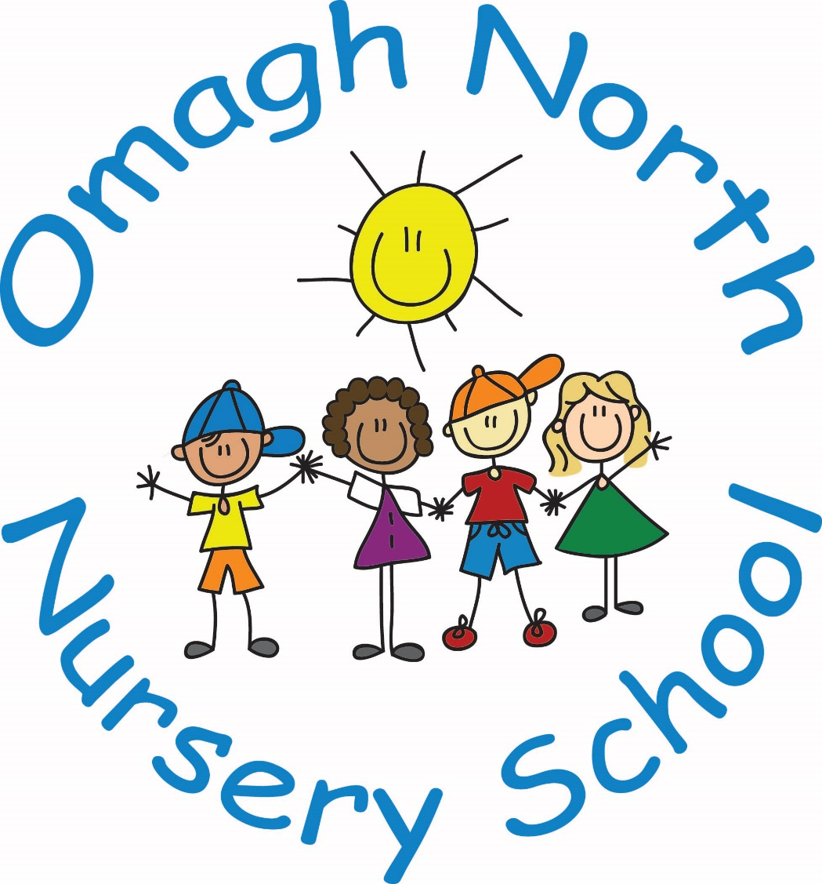

Reviewed and ratified by Board of Governors 15th June 2021

Signed: M Beattie Date: 15th June 2021
Chair of Governors
ABOUT US
Omagh North Nursery School is the data controller of the personal information we hold about our pupils and their parents/families/carers/legal guardians. This means that we are responsible for deciding how we hold and use the personal information which we collect.
We are required under the General Data Protection Regulation (GDPR) to notify you of the information contained in this privacy notice.
We collect and use pupil information under the Education Act (Northern Ireland) 2014 and other legislation. You may find the specific legislation at https://www.education-ni.gov.uk/department-education-legislation.
The majority of pupil information you provide to us is information which you are legally obliged to provide but some pupil information is provided to us on a voluntary basis. When collecting information from you we will inform you whether you are required to provide certain pupil information to us or if you have a choice in this.
This notice applies to prospective, current and former pupils and their families/carers/legal guardians and those applying for a place at the school and their families/carers/legal guardians. We may update this notice at any time but if we do so, we will inform you as soon as reasonably practicable.
It is important that you read and retain this notice, together with any other privacy notice we may provide on specific occasions when we are collecting or processing personal information about you, so that you are aware of how and why we are using such information and what your rights are under the GDPR.
If you have any questions about this privacy notice or how we handle personal information, please contact the Principal who will deal with your query. The Principal Mrs Amanda Duffy-Phillips, can be contacted on omaghnorthnursery@gmail.com, 02882 246431, or 64a Old Moutfield Road, OMAGH BT79 7EG.
Our Data Protection Officer is the Education Authority and it monitors the school’s data protection procedures to ensure they meet the standards and requirements of the GDPR. Please contact Data Protection Officer at Education Authority, Hospital Road, Omagh.
You have the right to make a complaint at any time to the Information Commissioner's Office (ICO), the UK supervisory authority for data protection issues. The ICO’s details are as follows:
The Information Commissioner’s Office – Northern Ireland
3rd Floor
14 Cromac Place,
Belfast
BT7 2JB
Telephone: 028 9027 8757 / 0303 123 1114
Email: ni@ico.org.uk

HOW DO WE COLLECT AND HOLD PERSONAL INFORMATION?
We collect some personal information about our pupils and their families/carers/legal guardians during a pupil’s application process to the school.
We will sometimes collect additional information from third parties such as the Education Authority, Department of Education, examination board or previous school attended by a pupil.
We mainly collect personal information about our pupils and their families/carers/legal guardians throughout the course of the pupil’s time at the school, for instance when completing educational visit consent forms, from statutory curriculum assessments and throughout our relationship with a pupil when we are exercising our legal obligations as a public educational body and during our pastoral care.
WHAT PERSONAL INFORMATION DO WE COLLECT, STORE AND USE ABOUT OUR PUPILS?
Personal information is information that identifies you and relates to you. We will collect, store and use the following categories of personal information about our pupils:
- Personal information (such as name, age, date of birth, photographs and unique pupil number)
- Contact information (such as address, emergency contact information and telephone number)
- Attendance information (such as sessions attended, number of absences and absence reasons)
- Assessment information (such as statutory assessment process, and assessment toolkits provided by commercial companies)
- Exclusion and behavioural information
- CCTV footage captured in school and other information obtained through electronic means
- Non-sensitive characteristic information (such as free school meal eligibility)
- Special categories of information (such as ethnicity, language, country of birth, nationality, information regarding health, special educational needs, allergies and disability).
WHAT PERSONAL INFORMATION DO WE COLLECT, STORE AND USE ABOUT OUR PUPILS’/ PARENTS/FAMILIES/CARERS/LEGAL GUARDIANS?
We will collect, store and use the following categories of personal information about our pupils’/parents/families/carers/legal guardians:
- Personal information (such as name, age, date of birth and photographs)
- Proof of Residence (such as copies of letters, bank statements etc)
- Contact information (such as address and telephone number)
- Financial information (such as payments made during course of year)
- CCTV footage captured in school and other information obtained through electronic means

WHY DO WE COLLECT, STORE AND USE THIS INFORMATION?
We will only use personal information when the law allows us to. Most commonly, we will use personal information relating to our pupils and their parents/families/carers/legal guardians where we need to comply with our legal obligations and where it is needed in the public interest for us to exercise our authority as a public educational body.
In some cases we may use personal information where it is necessary for our legitimate interests (or those of a third party) and your interests and fundamental rights do not override those interests. For example, the school has a legitimate interest in providing pupils with an education, safeguarding and promoting pupil welfare, facilitating the efficient operation of the school.
We may also use your personal information, less frequently to protect a pupil’s or their family’s interests (or someone else's interests). For example, when investigating a complaint made by another pupil.
We keep personal information electronically on a range of ICT packages on the school’s computer system, the School’s IT network, or manually in indexed filing systems.
Situations in which we will use personal data, including special category data, include:
- Teaching & Learning  For example:  - to monitor and report on pupil progress  - to provide appropriate pastoral care | - Statutory Returns  For example:  - to monitor equal opportunities
- Safeguarding & Child Protection  For example:  - to safeguard pupils  - to manage a pupil’s absence | - Security  For example:  - to comply with health and safety obligations  - to comply with the law regarding data sharing
- Business Continuity  For example:  - to assess the quality of our services | - Access to Systems  For example:  - to support pupil learning
- Communications  For example:  - to foster links between the school and the local community,  - including fundraising events | - Sound Financial Management  For example  - to provide more efficient means of payment for school facilities such as catering services

CONSENT
Whilst the majority of the personal data provided to the school is required for us to comply with our legal obligations, some of that information is provided on a voluntary basis through parental consent (namely, a parent’s/carer’s/legal guardian’s express agreement). However, if a child is not considered capable of giving consent themselves for example, due to an identified special educational need, an adult with parental responsibility may exercise the child’s data protection rights on their behalf.
Where we need consent, for example for the taking and displaying of photographs, the school will provide the person with parental responsibility for a pupil, with a specific and clear notice which explains the reasons why the data is being collected and how the data will be used. You should be aware if you do not consent to our collection of this type of data, this will not affect the standard of education we deliver to the pupil.
If we ask for your consent to use personal information, you can take back this consent at any time. Please contact the school if you would like to withdraw any consent you have given.
Please be aware that we do not need to obtain parental consent if personal data is to be processed for the purposes of obtaining counselling services for the child.
HOW LONG IS THE INFORMATION STORED FOR?
We will only keep personal information for as long as necessary to fulfil the purposes we collected it (for example, to educate and look after pupils) and including for the purposes of satisfying any legal, accounting, or reporting requirements.
We do not store personal data forever; we only hold pupil and family data for as long as we are legally able to do so. However, sometimes we will keep personal information for historical reasons (e.g. year group or sports team photographs) but you will always have a right to ask for it to be destroyed.
This is a link to the Department of Education Document Retention and Disposal Policy which can be found at https://www.education-ni.gov.uk/publications/disposal-records-schedule.This will give you more information about how long we keep personal information.
In determining the appropriate retention period for personal information, we consider the amount, nature, and sensitivity of the personal data, the potential risk of harm from unauthorised use or disclosure of your personal data, the purposes for which we process your personal data and whether we can achieve those purposes through other means, and the applicable legal requirements.
In some circumstances we may anonymise your personal information so that it can no longer be associated with you, in which case we may use such information without further notice to you.

DATA SECURITY
We have put in place appropriate security measures to prevent personal information from being accidentally lost, used or accessed in an unauthorised way, altered or disclosed. In addition, we limit access to your personal information to those employees, agents, contractors and other third parties who have a need to know. They will only process personal information on our instructions and they are subject to a duty of confidentiality.
We have put in place procedures to deal with any suspected data security breach and will notify you and any applicable regulator (currently the Information Commissioner’s Office) of a suspected breach where we are legally required to do so.

WHO WE SHARE PUPIL INFORMATION WITH
We may have to share pupil and their family’s data with third parties, including third-party service providers and other bodies such as:
- the new school/s that the pupil attends after leaving us
- the Department of Education
- the Education Authority for Northern Ireland
- Northern Ireland Council for Curriculum Examinations and Assessments
- The Board of Governors
- General Teaching Council for Northern Ireland
- Department of Health and Health & Social Care Trusts
- PSNI

WHY WE SHARE PUPIL INFORMATION
We do not share information about our pupils with anyone without consent unless the law and our policies allow us to do so. We only permit access to personal data for specified purpose and in accordance with our instructions.
We are required to share pupils’ data with the Department of Education and/or the Education Authority on a statutory basis. This data sharing underpins school funding and educational attainment policy and monitoring. We also share information with the NHS or a pupil’s destination upon leaving school.

Schools Census
The Department of Education has a legal right to ask for particular information under the Education and Libraries (NI) Order 2003 and is referred to as the “School Census”. This information includes information on pupil characteristics such as date of birth, gender, ethnicity, religion, free school meal entitlement and special educational needs status. A number of statistical releases are made available through the Department of Education website covering data on enrolments, participation rates, pupil teacher ratios, school leavers, attendance and school performance
TRANSFERRING INFORMATION OUTSIDE THE EEA
Whenever we transfer your personal information or that of your child outside of the EEA, we ensure that it is protected to the same standard as it would if it remained inside the EEA. Please contact the Principal if you would like further details on how we transfer your personal information outside of the EEA.
YOUR RIGHTS OF ACCESS, CORRECTION, ERASURE AND RESTRICTION
Under GDPR, pupils/parents/families and carers have the right to request access to information about them that we hold. To make a request for your personal information, or be given access to your child’s educational record, contact the Principal, Mrs Amanda Duffy-Phillips, on omaghnorthnursery@gmail.com, 02882 246431, or 64a Old Mountfield Road, OMAGH BT79 7EG.
We may need to request specific information from you to help us confirm your identity and ensure your right to access the information (or to exercise any of your other rights). This is another appropriate security measure to ensure that personal information is not disclosed to any person who has no right to receive it.
Under certain circumstances, by law a parent/carer/legal guardian or a child over the age of 13 (who is considered competent to do so) has the right to:
- Request access to personal information (commonly known as a "data subject access request"). This enables you to receive a copy of the personal information we hold about you and your child and to check that we are lawfully processing it. You will not have to pay a fee to access your personal information (or to exercise any of the other rights). However, we may charge a reasonable fee if your request for access is clearly unfounded or excessive. Alternatively, we may refuse to comply with the request in such circumstances.
- Request correction of the personal information that we hold about you and your child. This enables you to have any incomplete or inaccurate information we hold corrected.
- Request erasure of personal information. This enables you to ask us to delete or remove personal information where there is no good reason for us continuing to process it. You also have the right to ask us to delete or remove your personal information where you have exercised your right to object to processing (see below).
- Object to processing of personal information where we are relying on a legitimate interest (or that of a third party) and there is something about your particular situation which makes you want to object to processing on this ground. You also have the right to object where we are processing you and your child’s personal information for direct marketing purposes.
- Request the transfer of your personal information to another party, for instance a new school.

